https://www.groovypost.com/howto/enable-windows-7-hibernate-mode/:
Fixing Windows 7: Enable Hibernate Mode (groovypost.com)
Windows 7 doesn’t have a Hibernate option out of the box, as you might have noticed. However, you can bring it out of hiding and make it an option for you when powering down your PC. It takes a few more steps compared to enabling Hibernate mode in Windows 8, but it can be done. Here’s how.
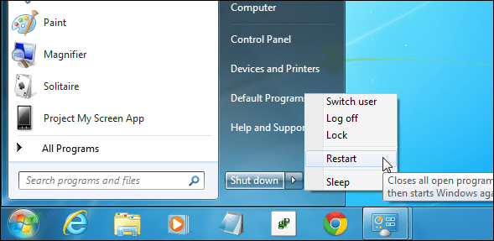
Editor Note: Since approximately half of the world’s computer users are still running Windows 7 and haven’t have upgraded to Windows 8.1, we’ve decided to start revisiting Windows 7 in this new series of articles on Fixing Windows 7. We’ll be covering some of the biggest Windows 7 annoyances and how to fix them. Also, if we have helpful tips or solutions that we never got around to, we’ll get those up as well. This week is how to uncover the hidden Hibernate option.
Update: If you skipped Windows 8 and upgraded directly to Windows 10, you saved yourself a lot of problems, so good on ya! The same power options exist on it as well. Make sure to check out our article on how to enable Hibernate on Windows 10 and our guide on how to shutdown, restart, hibernate, or sleep Windows 10.

Enable Hibernate in Windows 7
First click Start and Type: power options in the search box and hit Enter. Next in the right-hand pane select Change when the computer sleeps and then click Change advanced power settings.
In the Power Options window, expand Allow hybrid sleep and switch it to Off and click OK.
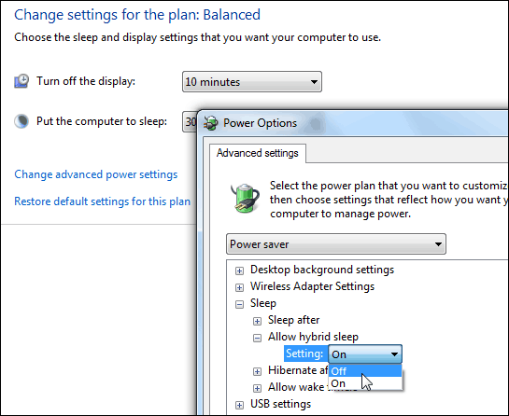
Now you’ll have your Hibernate option listed on the power button.
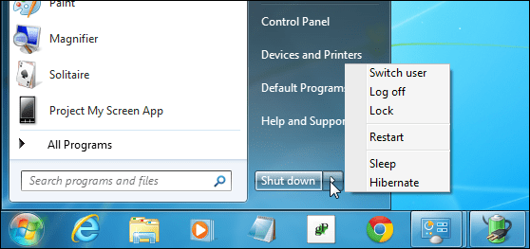
After enabling Hibernate, it will also show up in other locations, for example when you use the keyboard shortcut Alt + F4 to get the Shut Down Windows options.
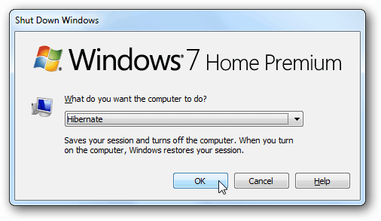
This adds the Hibernate feature and doesn’t replace anything, so you’ll still have the Restart, Log off, and Sleep options too. If you’re curious about the difference is between Sleep and Hibernate, check out our article: Understanding PCs and Devices: Sleep versus Hibernate.

